**Coefficient of Correlation research**

**Were Vincent**

**Coefficient of Correlation research**

**Introduction**

A correlation coefficient is a statistical indicator of how strongly and in what direction two variables are related (Field, 2013). It gauges how closely two variables are related to one another. It can quantify either the non-linear or linear relationship between two variables. It is represented by a number ranging from -1 to 1. The linear relationship between the two variables is stronger when the correlation coefficient is close to 1, and the negative linear relationship is stronger when it is close to -1. There is no association between the two variables if the correlation coefficient is 0. (Asuero et al., 2006).

However, both positive and negative correlations are included in the coefficient correlation. A statistical metric known as a positive correlation coefficient indicates a direct association between two variables in this context. Accordingly, as one variable rises, the other rises, and vice versa. A correlation value of 0.8, for instance, indicates that when one variable grows by one unit, the other variable will likewise increase by 0.8 units. The spss analysis takes this into account (Asuero et al., 2006)

In this concept, Positive correlation coefficients are used to identify relationships between variables in a range of scientific fields of psychology. A positive correlation coefficient can be used to measure the interaction between different personality traits. In addition, positive correlation coefficients can also be identified through other ways, such as regression analysis, which is fitting a line through data points to identify the relationship between two variables. The result of this analysis is an equation that can be used to predict the value of one variable given the value of the other.

A positive correlation coefficient is a statistical measure that identifies the relationship between two variables. It can identify relationships in various scientific fields and is typically found through regression analysis. Its value ranges from 0 to 1, with a value of 1 indicating a perfect linear relationship between the two variables.

A negative correlation in psychology refers to a relationship between two variables in which an increase in one variable is associated with a decrease in the other. It is the opposite of a positive correlation. Examples of negative correlations include higher levels of stress being associated with lower levels of job satisfaction, increased levels of anxiety being associated with decreased performance on tests, and higher levels of depression is associated with lower levels of self-esteem.

**1a)Scatterplot between the Adverts and Airplay**

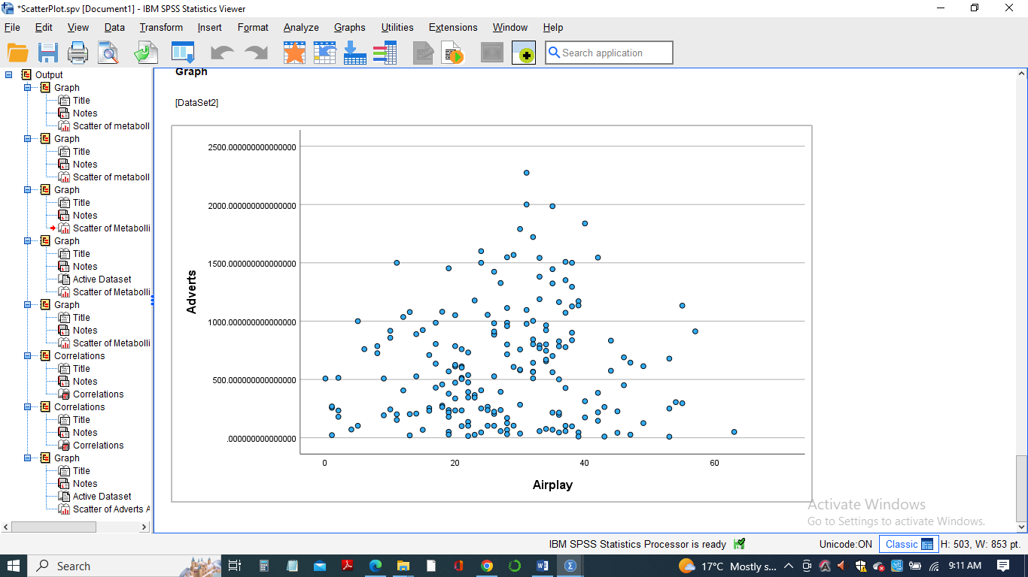

**1b)**

There exists a weak positive correlation between the Adverts and the Airplay variables.

There is a correlation coefficient of 0.102, which is not closer to the +1 correlation coefficient value. Thus there exists a weaker positive correlation between the two variables.

**2a)Matrix scatterplot relationships between Sales, Adverts, and Airplay**

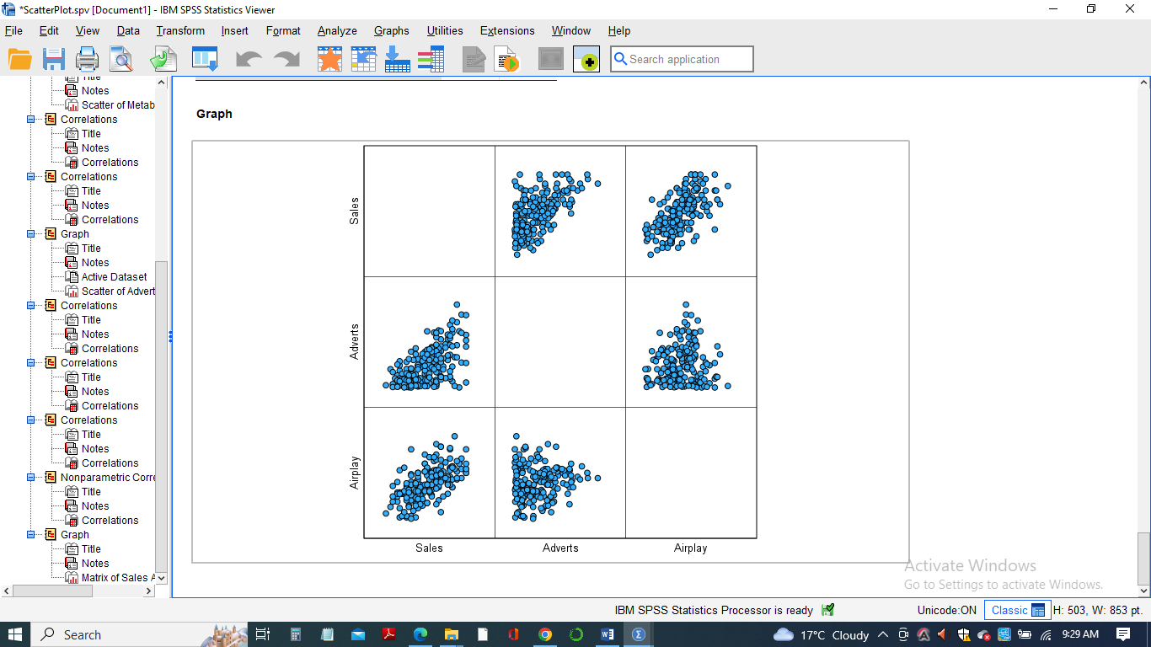

**2b)**

There is a strong positive correlation between the Sales and the Airplay variables. This is shown in the matrix scatterplot relationship showing that as the Sales increase, the Airplay decreases. As indicated by the Matrix scatterplots, there is a weak positive correlation between the Sales variables and the Adverts variables. This is because the scatterplots do not appear to be closer.

There is no correlation between the Airplay and Adverts variables, giving a correlation coefficient of zero. There is also a weak positive correlation between the Sales and Adverts variables from the Matrix Scatterplots.

**3a)** **Correlation between Adverts and Airplay**

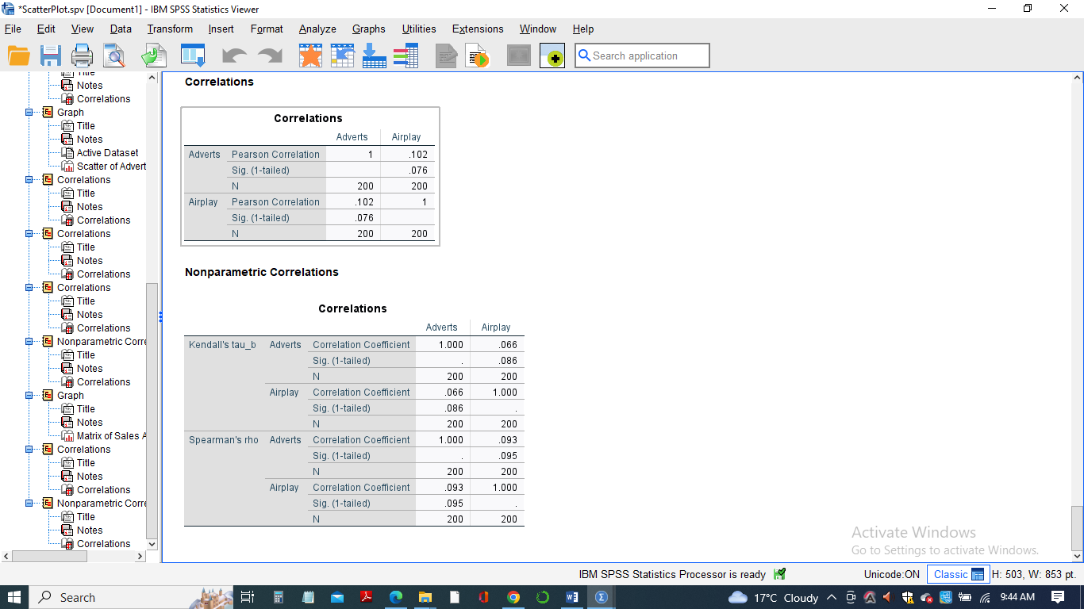

**3b)**

The Correlation ofAdvertsandAirplay where r=0.093 (r=0.093) based on the n=200 observations with pairwise non-missing values suggests a weak positive correlation since the far correlation coefficient value from the perfect correlation values of ±1.The r value of 0.093, therefore, suggests a weak positive correlation.

**4a) Correlation matrix between Sales, Adverts, and Airplay**

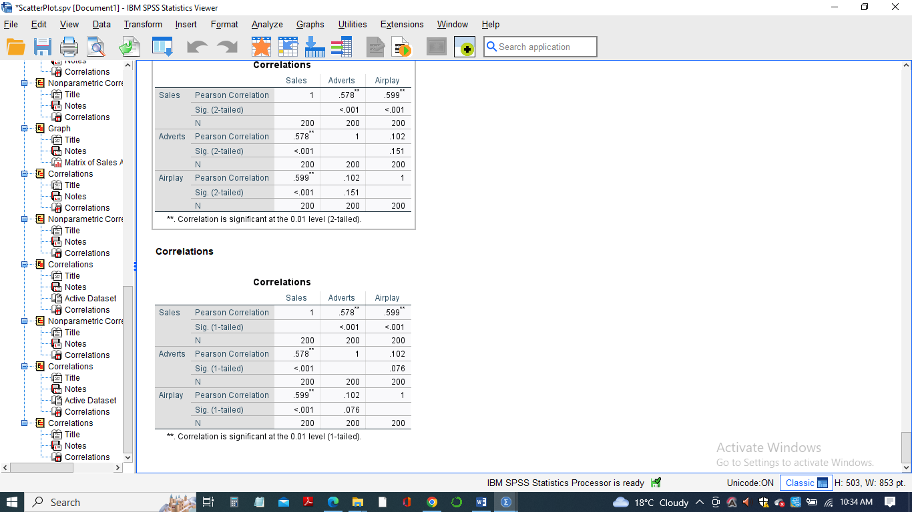

**4b)Nature of the correlation**

There exists a Significant correlation between the variables in the dataset. Both the Sales and Adverts variables and the Airplay and the Sales Variables have Significant correlations. The Sales and Adverts variables have a positive correlation of 0.578(r= 0.578), while the Airplay and the Sales variables have a significant positive correlation of 0.599 (r=0.599).

**5a)** **Create an example of two variables (unrelated to the Album Sales data set)**

Two hypothetical variable data set is created containing the Metabolic rates that represent the amount of energy used by an individual to complete a task and the corresponding Age values.

**5b)** **Scatterplot and Correlation using SPSS**

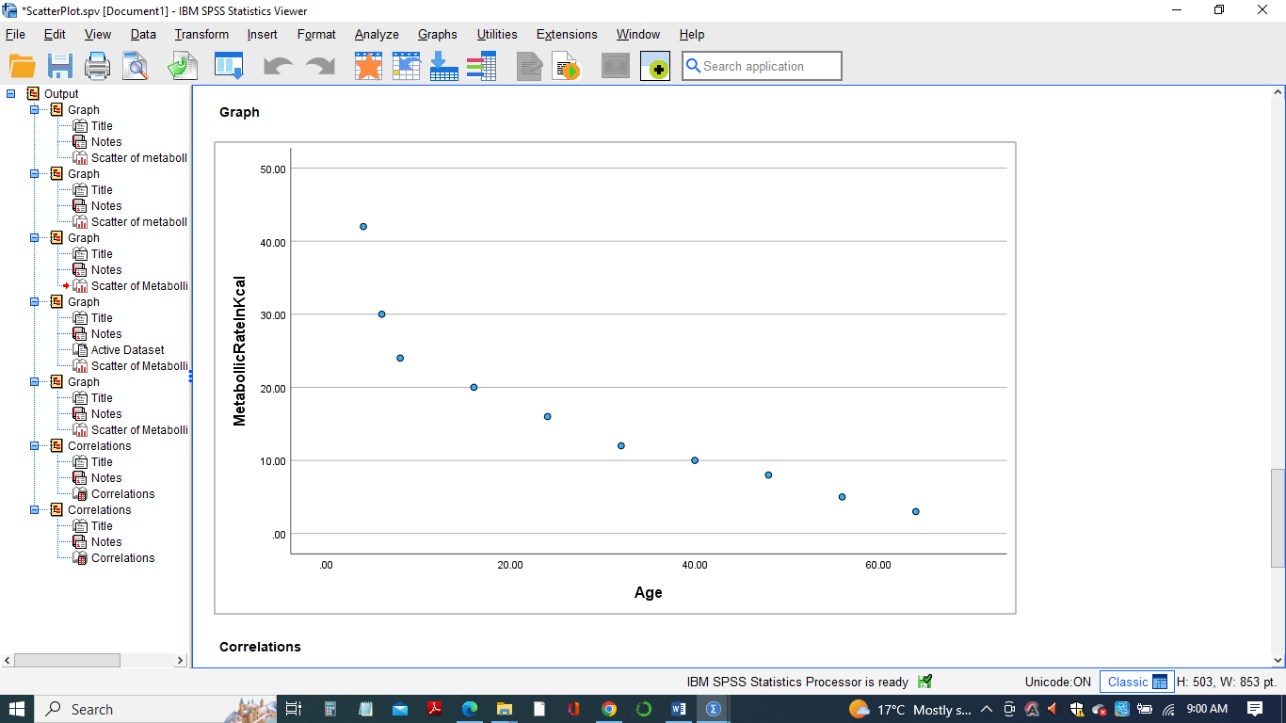

**5c)** **Correlation that exists in the hypothetical data set**

The correlation between the Metabolic rates and the Age Variables from the hypothetical dataset.

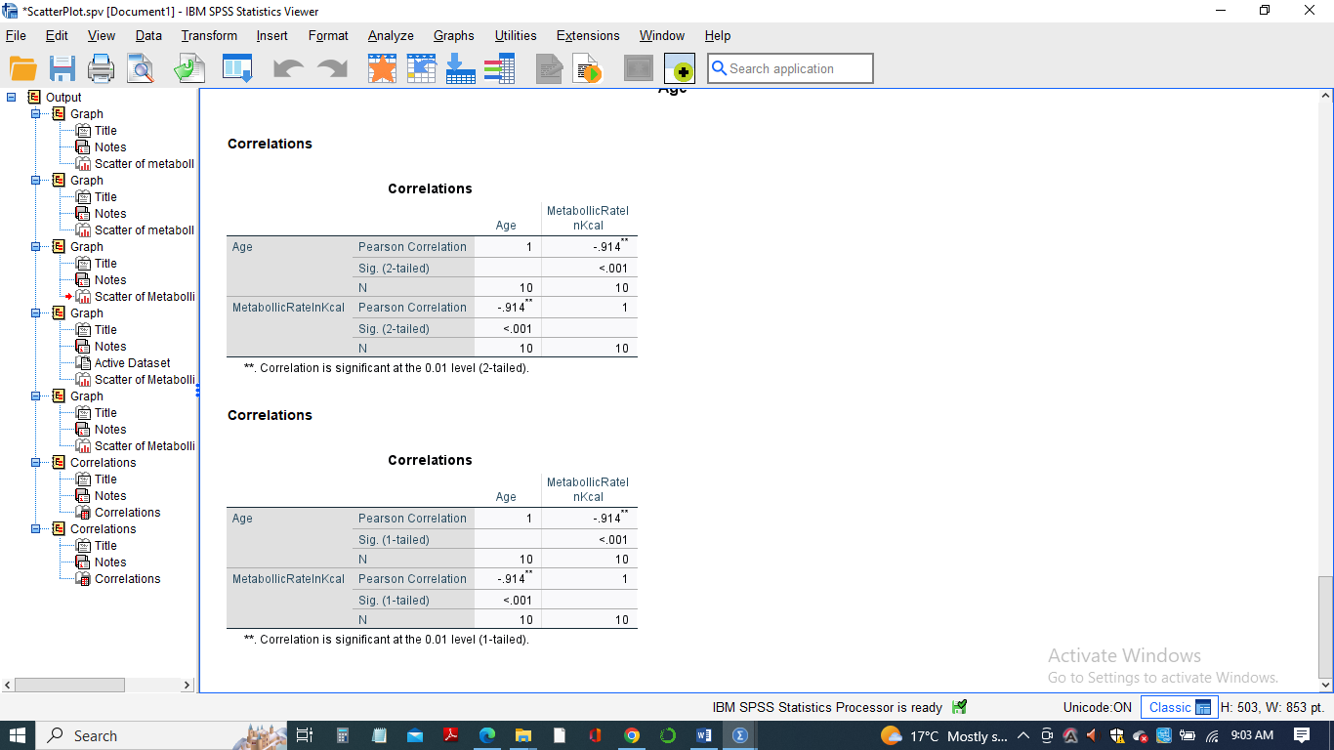

There is a negative correlation between the created variables, and this is because as the value of the age variable increases, the Rate of Metabolic reduces in kcal per hour. When an independent variable, Age, is plotted against the dependent Variable Metabolic rates and a scatterplot, a Correlation is determined to determine whether Negative or Positive. A strong negative correlation is realized between the two variables' relationship when a bivariate correlation is calculated and is found to be negative 0.914(r= -0.914) when N=10.

**Conclusion**

In conclusion, positive and negative correlation notions are crucial in psychological data analysis. Two variables are inversely associated if there is a negative correlation; when one variable rises, the other falls. Positive correlations show a direct relationship between two variables; as one measure rises, the other rises. Both are crucial metrics of the relationship between two variables that help us understand how people or groups behave.

**References**

Asuero, A. G., Sayago, A., & González, A. G. (2006). The correlation coefficient: An overview. *Critical reviews in analytical chemistry*, *36*(1), 41-59.

Field, A. (2013). *Discovering statistics using IBM SPSS statistics*. Sage. <https://scholar.google.com/scholar?q=A.+(2013).+Discovering+statistics+using+IBM+SPSS+statistics+(4th+ed.).+Thousand+Oaks,+CA:+Sage+Publications,+Inc.&hl=en&as_sdt=0&as_vis=1&oi=scholart>